  
  Pediatric Congenital Cardiac Pathology and Cardiomyopathies; Pediatric Cardiac sonography
  Hospital Lecture Series
  Memorial Hospital would like to invite all Prehospital EMS and Emergency Department personnel to attend a 2 hour lecture on Pediatric Congenital Cardiac Pathology and Cardiomyopathies; followed by an explanation of Pediatric Cardiac Sonography. CE hours offered to EMS and Nurses free of charge! This is part of the 1st Friday of the Month Hospital Lecture series that will continue throughout the 2016 Calendar Year. This presentation will be given on March 4th 2016 from 1300-1500 at the Memorial North Hospital, Pine Creek Room. (2nd floor near the gift shop)
  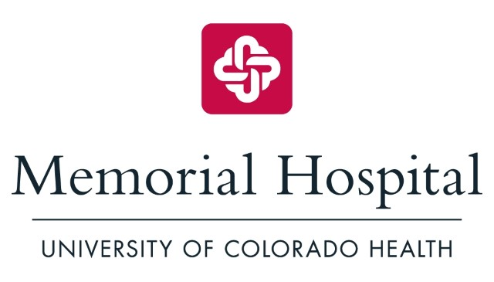
  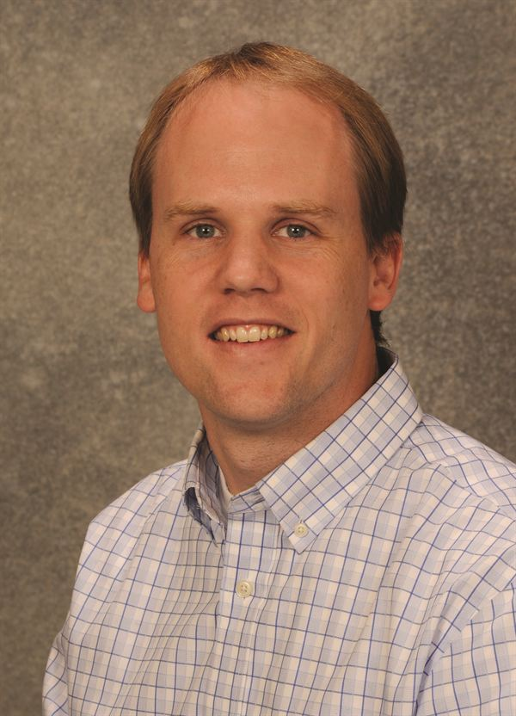Dr. Chad Stewart MD Pediatric Cardiologist
  Heather Schallenberger Pediatric Cardiac Sonographer
  Memorial North Hospital 4050 Briargate PKWY Colo Spgs CO 80920
  Beverages will be provided by the Memorial Hospital EMS Department.

