
Penrose-St. Francis EMS Institute Presents:

ACLS Refresher Course

Tuesday, March 21, 2017
9am - 12:30pm

Tri-Lakes Monument Fire Rescue, Station 1
18650 CO-Hwy 105, Monument, CO 80132
(719) 484-0911

Cost: $15/person (cost of card)
PLEASE BRING YOUR CURRENT ACLS CARD WITH YOU TO CLASS

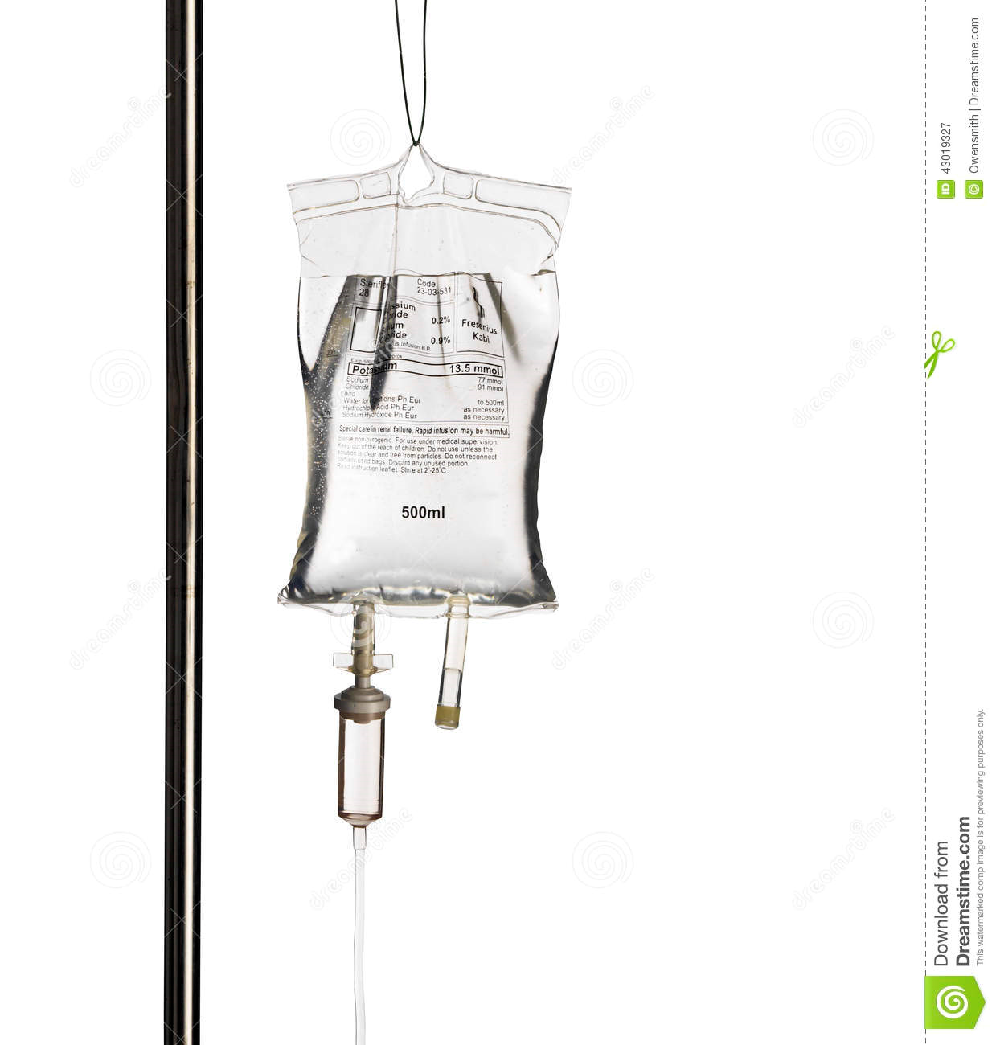
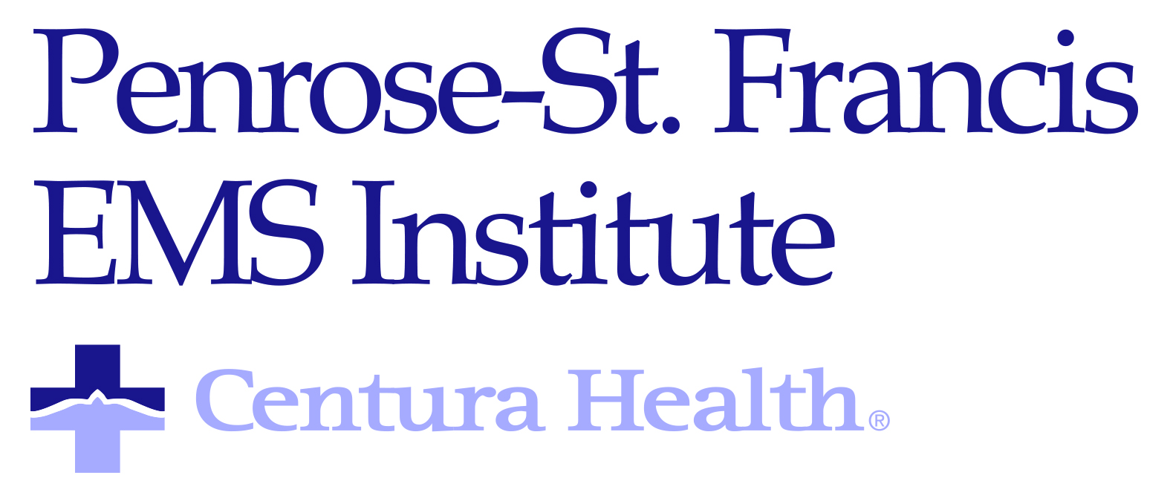
TARGET AUDIENCE:
Paramedics, Nurses, Doctors, RTs, etc. (EMTs may audit the course for EMS CE)

To Register:
Follow the link: https://reg.abcsignup.com/reg/event_page.aspx?ek=0028-0016-3446aefbd60646b4a5a01a3462b0b1b0
Or go to; www.penrosestfrancis.org, select ‘About Us’, then Calendar of Events, then under the Audience box select EMS providers.
Questions? Contact Dave Mead davidmead3@centura.org, 719-776-7798

Questions? Contact Dave Mead, davidmead3@centura.org or (719)-776-7798

