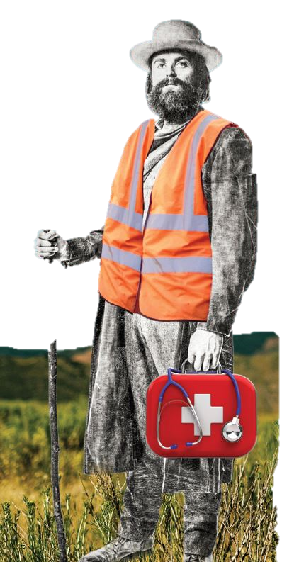
Penrose-St. Francis EMS Institute Presents:

PALS Refresher Course

Tuesday, March 21, 2017
1pm - 4:30pm

Tri-Lakes Monument Fire Rescue, Station 1
18650 CO-Hwy 105, Monument, CO 80132
(719) 484-0911

Cost: $15/person (cost of card)
PLEASE BRING YOUR CURRENT PALS CARD WITH YOU TO CLASS

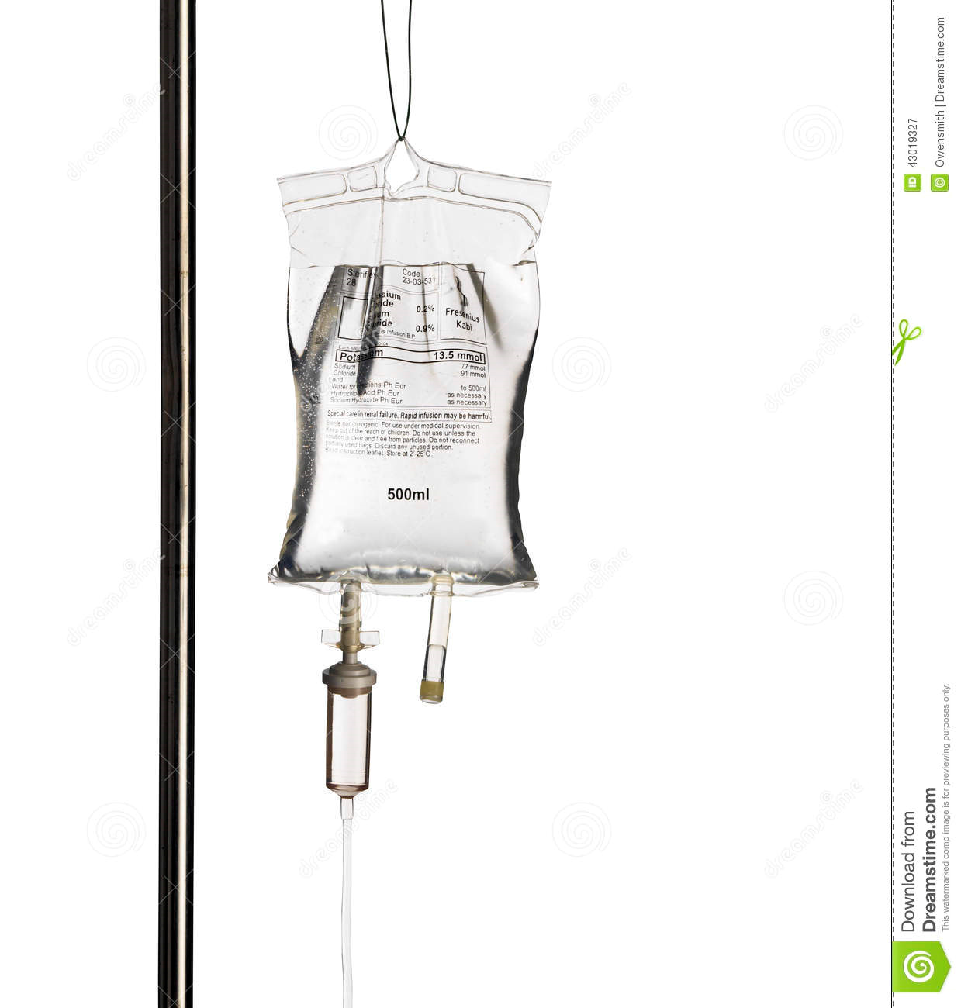
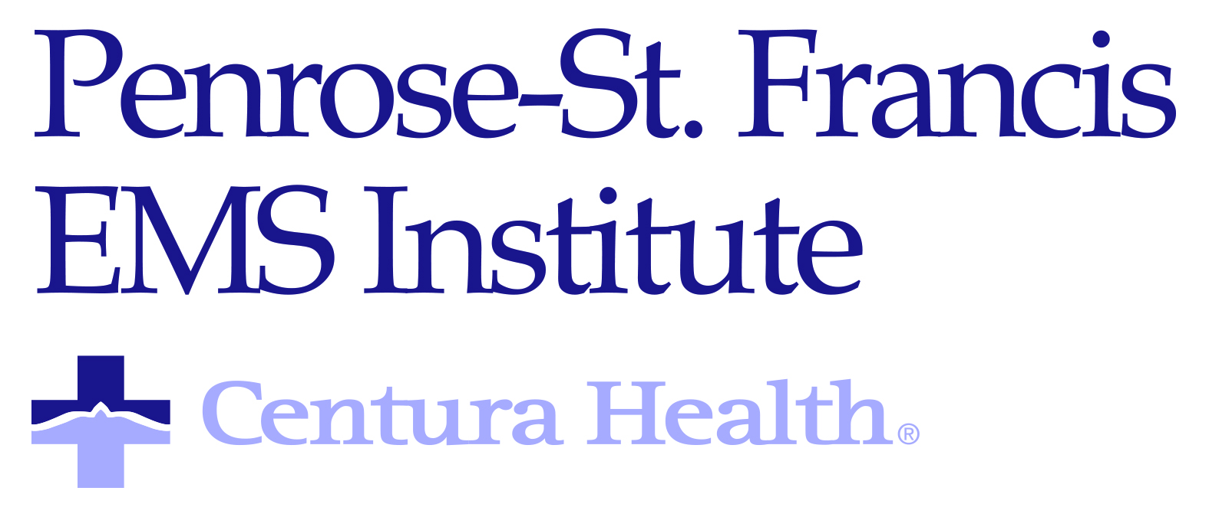
TARGET AUDIENCE:
Paramedics, Nurses, Doctors, RTs, etc. (EMTs may audit the course for EMS CE)

To Register:
Follow the link: https://reg.abcsignup.com/reg/event_page.aspx?ek=0028-0016-fff6cf5703f54ac4b0017638367aea2e
Or go to; www.penrosestfrancis.org, select ‘About Us’, then Calendar of Events, then under the Audience box select EMS providers.
Questions? Contact Dave Mead, davidmead3@centura.org (719)-776-7798

Questions? Contact Dave Mead, davidmead3@centura.org or (719)-776-7798

